Project
SPECIFICATION

SD292 - Trabalho Orientado II

NOMBRE DEL PROYECTISTA
Date: November 19, 2025
Rev.: 1.0

- Document Versions

Version Number | Date | Author | Summary of Changes
1.0 |  | Aluno | First SPEC version. Contains all block specification

- Acronyms

AI Artificial Intelligence
ASIC Application Specific Integrated Circuit
FSM Finite State Machine
HDL Hardware Description Language
CLK System clock signal
- Overview
Example
The Blackjack or “21” card game is a well known card game. Is is based on betting on a sequence of cards that must have the higher score in table. The score is due to the sum of the cards and must not go over “21” otherwise the player loses. The value of the cards to compute the sum and details of the game itself will be further discussed in this document.
- RTL Design
This design is implemented using industry standard Hardware Description Language (HDL), meant to run either on prototyping hardware or as a module on an ASIC. It defines a FSM designed to control a game system for distributing cards and compute win, lose or tie outputs. It also computes movement decisions for the electronic dealers AI.

  - Modular Design
This design is a module of a larger system. The top level system is a hand-held electronic game. It consists of the present FSM, plus console interface, that is keyboard and video output.
  - FSM Design
A standard FSM design has three main blocks, as stated before:
- State transition logic;
- Output logic;
- Current state register.

  - Feature Requirements
Rules or requirements of block (limitacoes e alcance do bloco)

- System Design Overview
  - The Block Interface
The FSM required to implement the design is a synchronous reset Moore FSM. Its inputs and outputs are shown in Figure and described in Table.
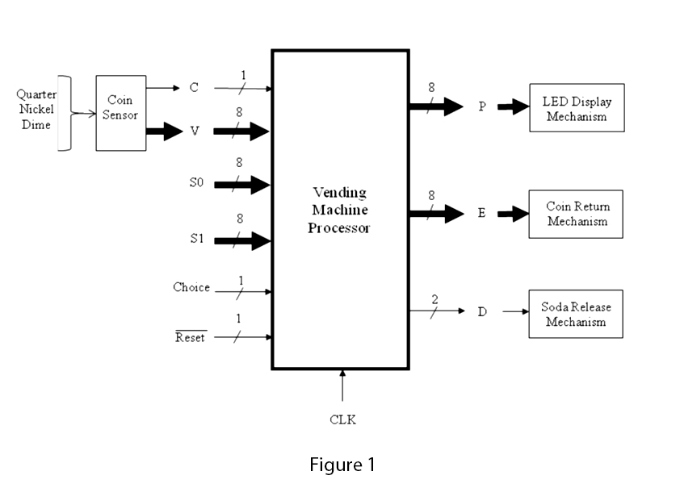

Describe Inputs and outpus of block
Name | Input/Output | Description
clk | I | System clock
rst | I | Reset signal

To estimate chip size the following parameters should be used.
● Clock of 100 MHz
● Power consumption of 6mW
● Area of 1mm²
● Technology used 0.6um
● Foundry X-Fab

  - Next State Logic
The next state logic block should be able to compute proper next state value to meet FSM transition state requirements. This block is also responsible of defining winning, losing or tie next states from a given current state.
  - Output Logic
The output logic is much simpler than the Next State Logic. The three outputs will be zero (0) all the time, since a reset signal is activated. If the state that defines player as winner is reached, the WIN output will be set to one (1).
  - State Register
The State Register block just stores current state information. This information is updated from the Next State block output in the rising edge of the clock signal. The Figure 6 shows State Register inputs and output
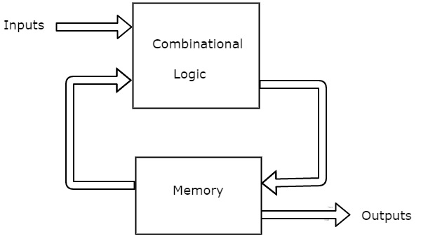
- APPENDIX A:
  - anexos

